**信息解读：**

Consider the following problem description: A mail-order company wants to automate its order processing. The initial version of the order processing system should be accessible to customers via the web. Customers can also call the company by phone and interact with the system via a customer representative. It is highly likely that the company will enhance this system in upcoming years with new features. The system allows customers to place orders, check the status of their orders, cancel an existing order and request a catalog. Customers may also return a product but this is only possible through the phone, not available on the web. When placing an order, the customer identifies himself by means of customer number (only for existing registered customers) or by means of his name and address. He then selects a number of products by giving the product number or by selecting products from the online catalogue. For each product, information such as price, a description and a picture (only on demand as they are usually high-resolution images of large size) are presented to the customer. Also the availability of the product is obtained from the inventory. The customer indicates whether he wants to buy the product and in what quantity. When all desired products have been selected, the customer provides a shipping address and a credit card number and a billing address (if different from the shipping address). Then an overview of the ordered products and the total cost are presented. If the customer approves, the order is submitted. Credit card number, billing address and a specification of the cost of the order are used on the invoice, which is forwarded to the accounting system (an existing software module). Orders are forwarded to the shipping company, where they are filled and shipped. Customers who spent over a certain amount within the past year are promoted to be gold customers. Gold customers have additional rights such as being able to return products in an extended time period as well as earning more bonus points with each purchase. In addition, in cases where a product is on back order, gold customers have the option to sign up for an email notification for when the particular product becomes available.

**自做版本：**

**1.用例图**

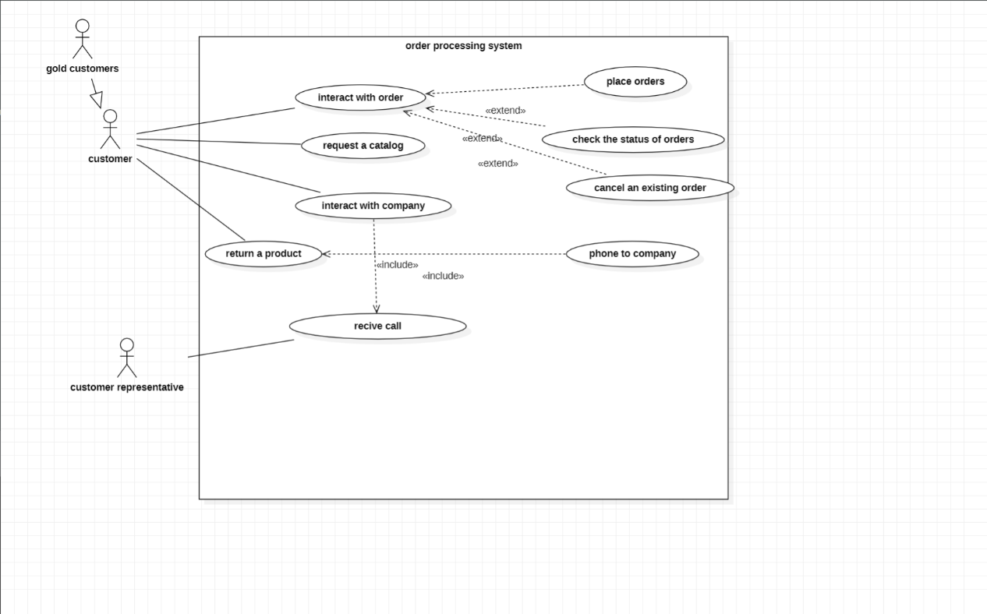

**2.类图：**

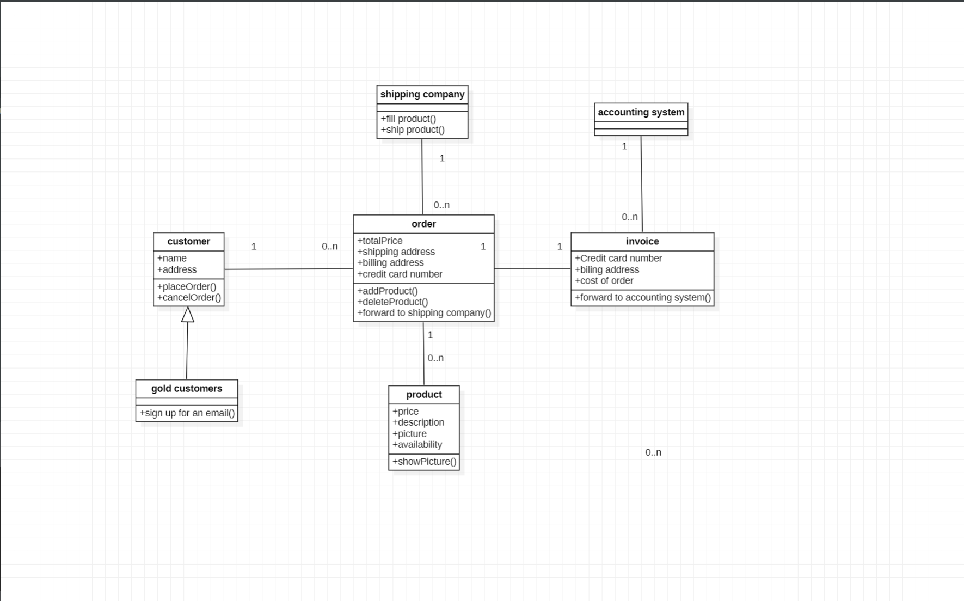

**3.顺序图：**

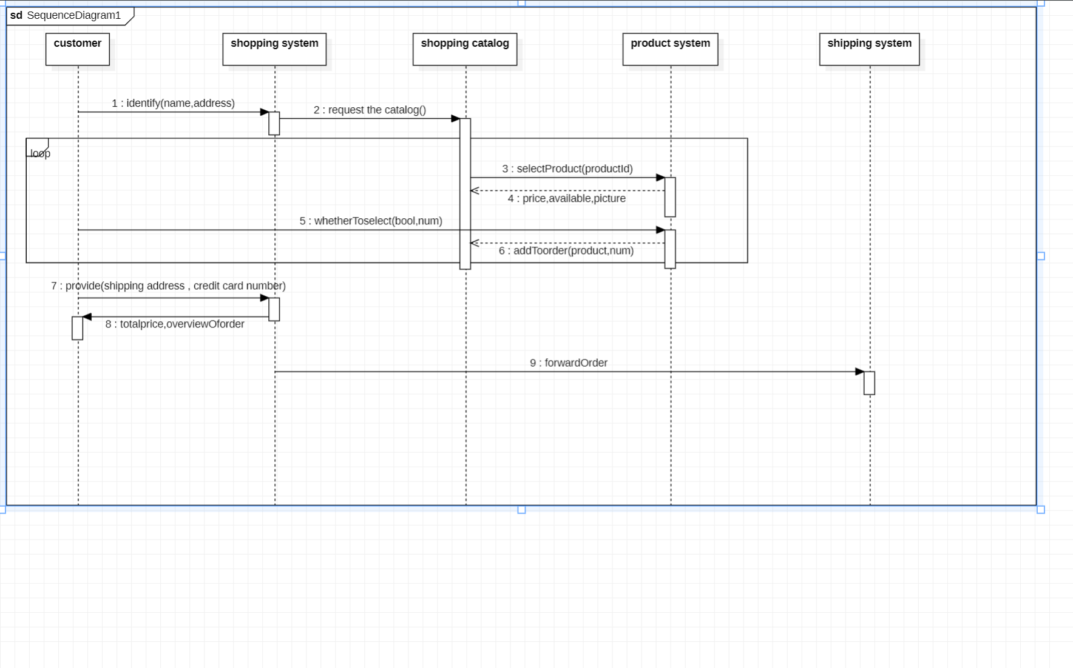

AI辅助更改版本：

1. **用例图**

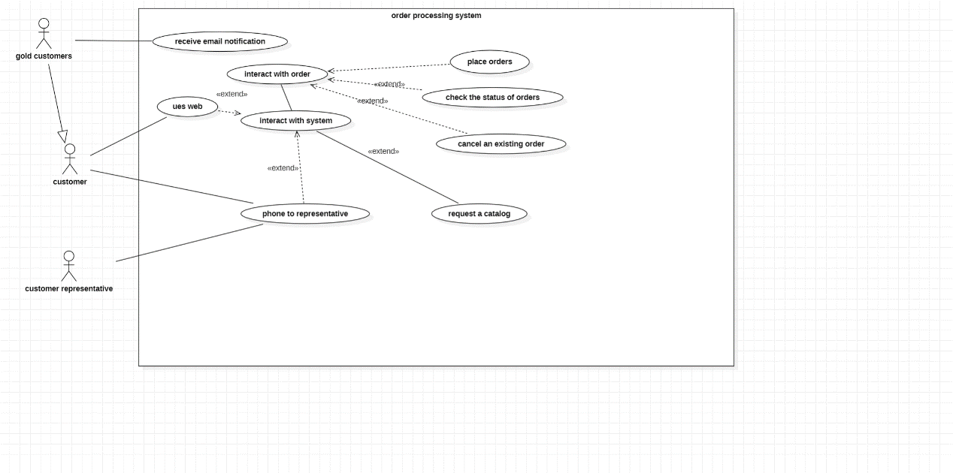

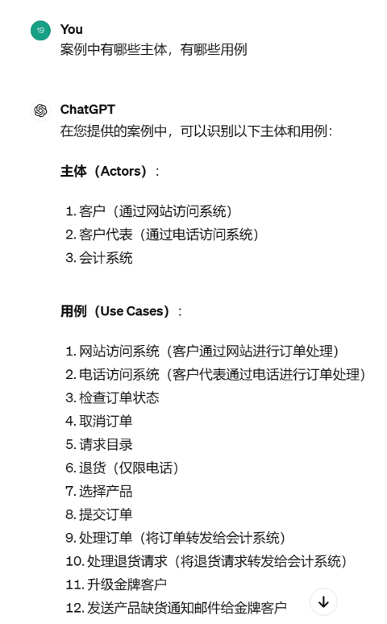AI选择将会计系统作为主体，个人认为会计系统作为一个系统模块，通常不会被直接表示为主体。

删去了下面的外部反馈用例

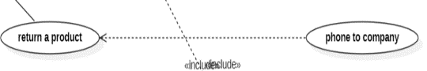

对于其提供的大部分用例初版均已提出，而对于初版未出现的用例，AI提供的1和2让我意识到自己理解错了通过客户代表来交互。应该是客户能够通过浏览网页和给客户代表打电话两种方式来与系统交互完成购物操作

修改了下面的交互

修改前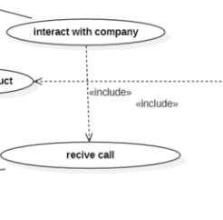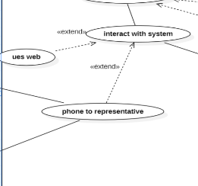修改后

**2.类图：**

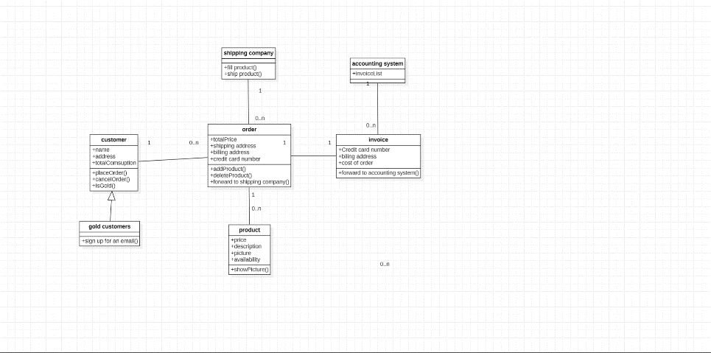

AI给出的Catalog，CreditCard，Address类个人觉得都不应该出现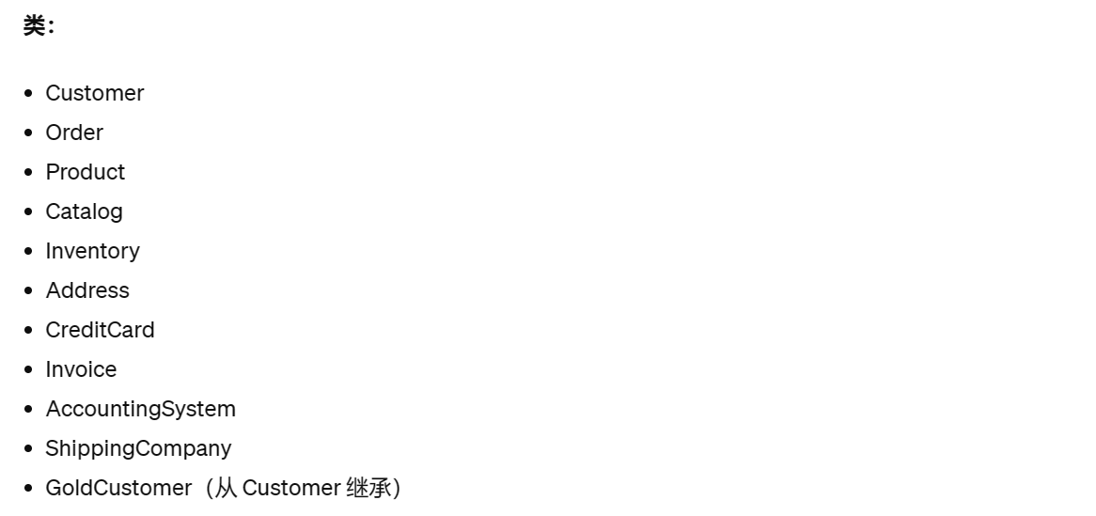



增加了customer的方法属性，来表示客户累积消费金额与是否为金牌用户

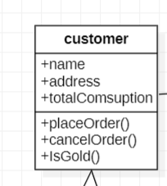

3.顺序图:

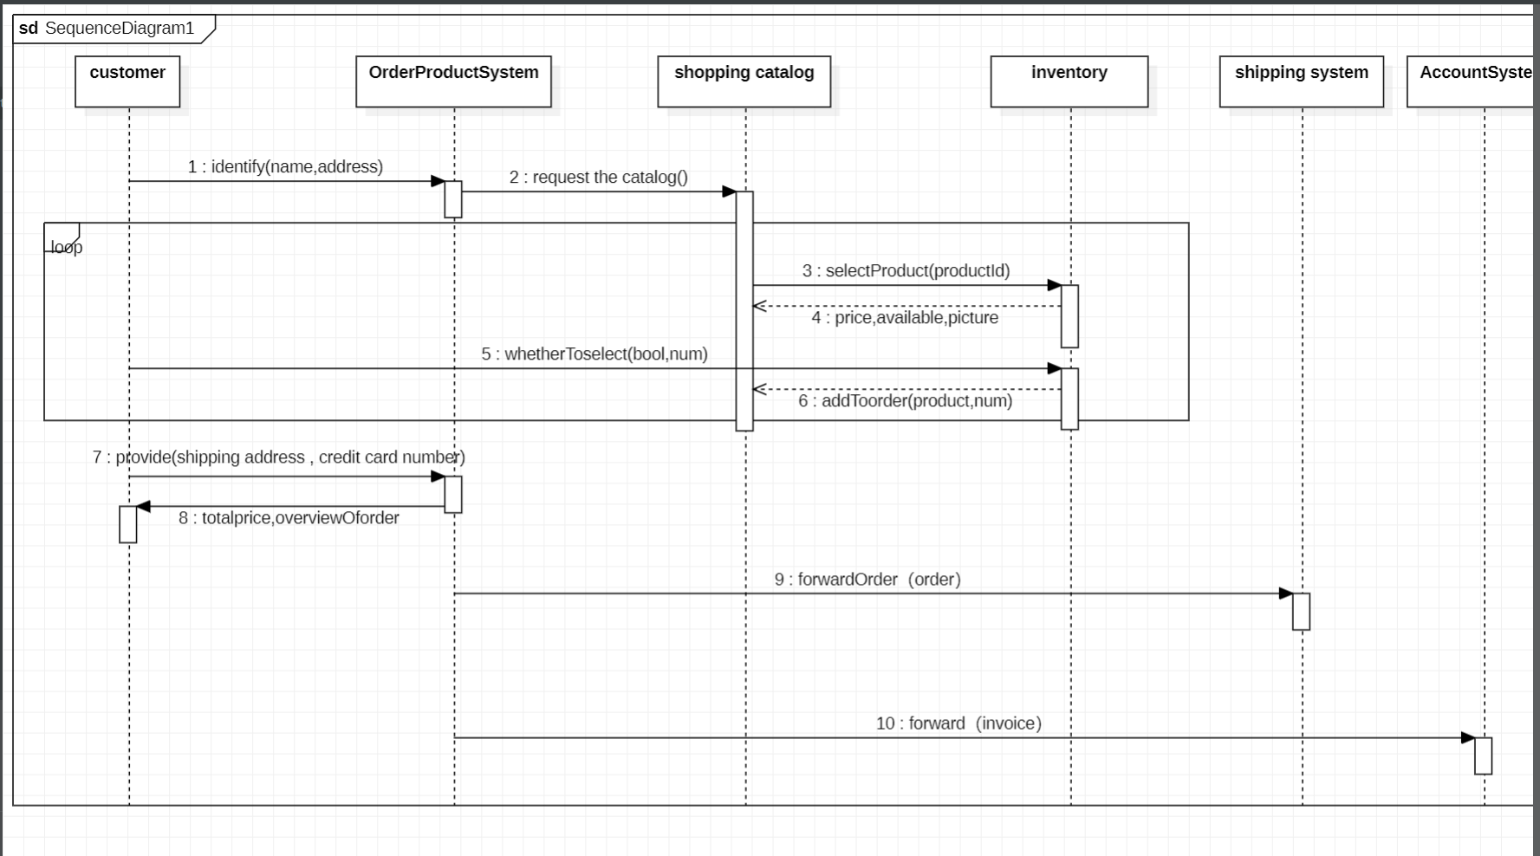

增加了库存主体来检查货物是否有存量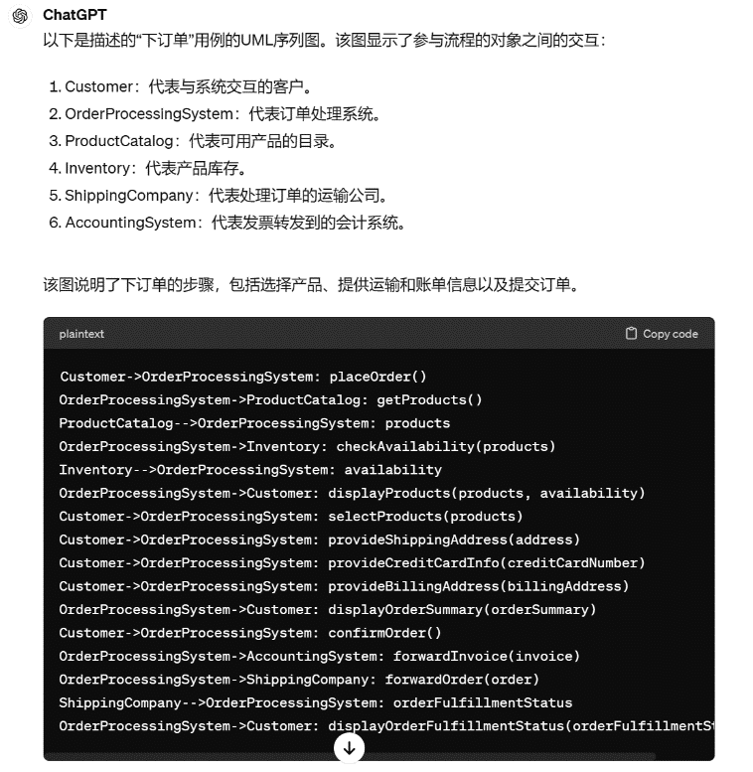

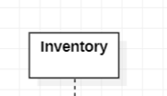

更改了之前两个shippingSystem的错误问题

并添加了AccountingSystem

AI模型总体框架跟个人较为类似

总结：

1. 完成时间（自做加ai辅助修改）

用例图：30分钟左右

类图40分钟左右

顺序图40分钟左右

1. Ai提问

基本询问各图的组成方式，与基本逻辑，还有对gpt给出的回答我不能理解的地方，总共问了有七八句

1. 具体内容

